Forests for Tomorrow

Current Reforestation and Timber Supply Mitigation

Strategic Plan

2011 to 2015



Table of Contents
i
Introduction 1
Forests For Tomorrow 3
Vision 3
Mission: 3
Goals 3
Goal 1: Improve the mid and long-term timber supply and establish resilient forest ecosystems. 4
Goal 2: Best return from investments and activities on the forest land base. 3
Goal 3: Improved decision-making in delivering forest reforestation and restoration activities. 7
Goal 4: Safety is a fundamental component of all activities and considerations. 3
Appendix A Performance Measures 10
Goal 1: Improve the long term timber supply and establish resilient forest ecosystems and habitat, through reforestation. 10
Goal 2: Best return from investments and activities on the forest land base. 10
Goal 3: Improved decision-making in delivering forest reforestation and restoration activities. 10
Goal 4: Safety is a fundamental component of all activities and considerations. 11

Introduction
Silviculture is defined as “the art and science of controlling the establishment, growth, composition, and quality of forest vegetation for the full range of forest resource objectives” (Ministry of Forests, 2000).
Today, “[t]he forests of British Columbia are being impacted by the dynamics of environmental change and human activity in ways that were unforeseen only a decade ago. Many of the assumptions that forest management professionals have relied upon to plan for the growing and harvesting of trees and for management of other important ecological services, no longer appear valid, or at least require re-examination.” (MFR, 2006a)
In response, the Province of British Columbia established the Forests for Tomorrow (FFT) program in 2005 with the aim of improving the future timber supply and mitigating impacts on other forest values.
Broadly, through the FFT Current Reforestation and Timber Supply Mitigation Strategic Plan, the Ministry of Forests, Lands and Natural Resource Operations (FLNRO) supports these goals as outlined in 2011/12 – 2013/14 Service Plans and other government land base priorities (Appendix A):
1) maximum productivity of forest resources (MFML),
2) sustainable development of forest resources(MFML)
3) coordinated, integrated and sustainable management, development and use of natural resources (MNRO).
The focus will be on the strategic objectives of:
1) Best return from investments and activities on the forest land base,
2) Encourage investments to benefit forest resources
In achieving these strategic objectives the strategic priorities will be to:
- Manage impacts on forest resources from pests, disease, and wildfire.
- Mitigate mid-term timber supply shortfalls
- Maximize timber grown in the provincial forests
  - performance measure of an annual timber volume gain of 6.8 M m3 (millions of cubic metres) from silviculture investments
This FFT strategic plan establishes the vision, mission, goals, and performance measures that will guide the program over the next five years.

Forests For Tomorrow

Vision
The impacts of catastrophic disturbances and constrained timber supplies are, effectively and efficiently, mitigated by stand tending and reforestation while supporting forest resilience.

Mission:
Reforest and manage productive forest land and environmentally sensitive areas.

Goals
Addressing future shortfalls in the timber supply caused by catastrophic disturbance is the leading priority for the current reforestation and timber supply mitigation programs of Forests For tomorrow.
In its efforts to restore damaged timber, FFT will undertake the practices and strategies necessary to ensure that the future forests will be resilient to current and future threats.
Forests For Tomorrow activities also provide additional benefits to communities through the creation of sustainable future forests and locally driven employment opportunities.
Forest For Tomorrow’s goals reflect a range of environmental and social values adversely impacted by catastrophic disturbance. The goals, plus their associated objectives and strategies, are described below:

Goal 1: Improve the mid and long-term timber supply and establish resilient forest ecosystems.
Objectives
  - Maximize volume timber grown in provincial forests
  - Mitigate mid-term timber supply shortfalls
  - Rehabilitate damaged stands to produce future volume at a level commensurate with timber supply expectations
  - Achieve the best return on investment through the strategic selection of treatment areas.
  - Policies are adaptive and responsive to current research regarding climate change, forest health, and silviculture.
  - Annual business and treatment plans are consistent with higher level land use plans and provincial priorities.
  - Impacted landscapes are managed for the restoration of non-timber values in concert with reforestation activities to restore the productivity of various forest resources.
Strategies

  - Focus reforestation, restoration, and stand tending activities on the most productive sites in those management units which have had the greatest negative impact on future timber supply and other forest values.
  - Survey program implemented on a scale necessary to establish and maintain a 3 year plan.
  - Utilize a Multiple Accounts Decision Analysis (MADA) to target sites that optimize economic, environmental, and social values.
  - Maintain adequate growth rates on stands established under FFT until a free growing state has been achieved.
  - Ensure that species and spatial diversity is being achieved
  - Utilize select seed with superior growth, form, and fibre quality and pest resistance for reforestation.
  - Maintain sufficient seed supplies to meet FFT reforestation needs.
  - Incorporate up-to-date knowledge on climate change forest health factors, and other arising issues into all silviculture practices
  - Investigate and incorporate opportunities for synergies with other funding initiatives (e.g carbon markets).
  - Report and record information that supports accurate timber supply forecasting as well as silviculture planning.
  - Consider and document measures for addressing non-timber values in all site preparation, reforestation and stand tending activities

Goal 2: Best return from investments and activities on the forest land base.
Objectives
  - All reforestationand stand tending projects will realize a return on of investment in excess of 2%
  - Optimize wood-fibre utilization opportunities arising from FFT activities.
Strategies

  - Review and update the return on investment process to ensure that the right types of stands are managed to achieve a targeted return on investment.
  - Promote local community access to low value/low volume fibre supply derived from stand rehabilitation.
  - Optimize multiple resource benefits arising from stand rehabilitation
  - Ensure that local representative have opportunities to provide input into program plans.
  - Increase community awareness and involvement (e.g., brochures, internet, trade shows, and presentations).

Goal 3: Improved decision-making in delivering forest reforestation and restoration activities.
Objectives
  - Informed decisions are made by incorporating the best knowledge and account for flexibility required to deal with uncertain futures (e.g. climate change, fluctuating economic conditions)
  - Develop and implement innovative approaches to reforesting forests damaged by catastrophic disturbance
  - Achievement of goals is evaluated and continuous improvement techniques are employed.
  - Shared program leadership built on collaboration to achieve the common vision.
  - Operate with purpose, pride, and commitment under a formal documented continuous improvement program.
  - Shared accountability for achieving program goals.
  - Develop and implement performance measures to accurately report on the delivery of program objectives.
  - Management practices are cost effective.
Strategies

  - Engage stakeholders in the development of strategic and tactical plans.
  - Analyze and understand the cost-benefit of proposed silviculture treatments prior to executing them.
  - Utilize a “scenario planning” approach to consider the program’s effectiveness under a variety of plausible future outcomes.
  - Employ a community of knowledge approach to sharing of information on techniques and strategies.
  - Review, evaluate, and share best practices.
  - Identify and remove barriers to success.
  - Update, evaluate and improve FFT standards with respect to increasing efficiency and risk management.
  - Conduct regular program audits, evaluations and monitoring in a continuous improvement framework.
  - Develop consistent protocols for Quality Assurance across the program.
  - Review strategic and tactical plans annually to determine their relevance to changing factors.

Goal 4: Safety is a fundamental component of all activities and considerations.
Objectives
  - Significant contributor to improved safety in the B.C. forest sector.
Strategies

  - Ensure that clear communications structures are in place at all levels to facilitate Safety knowledge sharing.
  - Utilize companies with ®“Safe Company” Certification.

  - Track and measure safety performance
  - Strive to eliminate workplace injuries.
  - Create and maintain an effective FFT health and safety program, to which all employees are accountable.

Appendix A Performance Measures

Goal 1: Improve the long term timber supply and establish resilient forest ecosystems and habitat, through reforestation.
- Hectares surveyed, site prepped, planted, brushed, fertilized, spaced, and pruned per year.
- Volume gained through treatments.
- Number of management units with updated inventory, silviculture strategies and tactical plans built using Multiple Accounts.
- Percent area planted with more than one tree species, and percent area planted with lodg pole pine
- Percent of free-growing stand composition that is pine.
- Amount of seed owned by FFT
- Amount of select seed (% Class A, Average genetic worth) sown by FFT

Goal 2: Best return from investments and activities on the forest land base.
- Volume produced 65 years into the future
- Average Site index of areas treated
- GDP 65 years into the future
- Tonnage of CO2e sequestered 65 years into the future
- Cost/ha of restored forest land
- Volume of wood-fibre utilized through FFT activities.

Goal 3: Improved decision-making in delivering forest reforestation and restoration activities.
- Number of type 2 silviculture strategies upgraded.
- Number of program components evaluated
- Per cent of total program expenditures allocated to overhead.
- Per cent of program audits with no major non –conformances
- Communication effectiveness feedback, trends from surveys – needs benchmarking and consistent follow-up questions

Goal 4: Safety is a fundamental component of all activities and considerations.
- Benchmark and track accidents and incidents

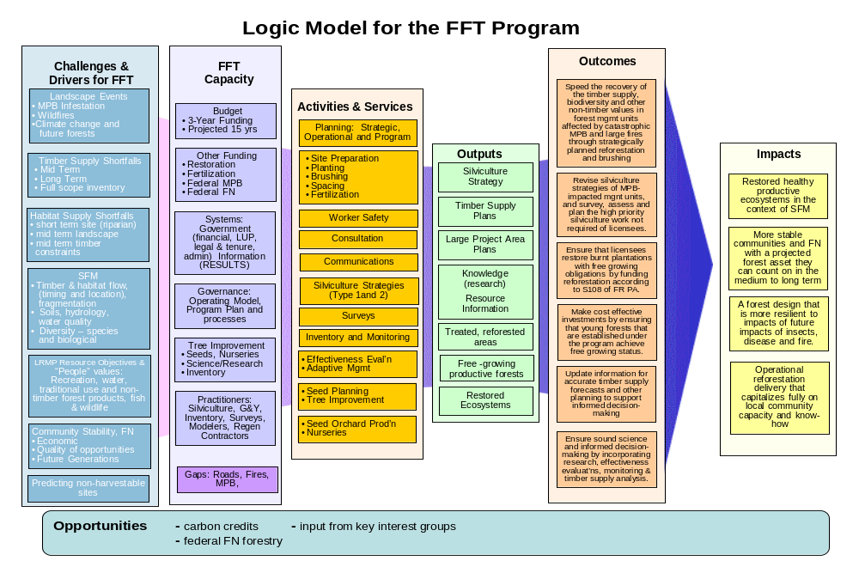

Reforestation of areas impacted by catastrophic disturbance
Reforestation of areas impacted by catastrophic disturbance
Activities that increase short-, mid-, or long-term timber supply
Overall intention for management
Former Ministry of Forests, Mines, and Land (MFML) and the foremer Ministry of Natural Resource Operations (MNRO)
The strategic conditions that need to be attained to achieve a goal.
FFT will expand the use of performance indicators as a management tool, as resources permit.

